The Figure below shows the results of a survey done in USA. Approximately 250 000 men were studied for more than 12 years, and those who died had their cause of death examined. The graph shows the variation with average alcohol consumption of the mortality rate for three such causes, together with the variation in mortality rate from all causes. Coronary Heart Disease (CHD) is a particular and common cardiovascular disease. Mortality rates are shown as a proportion of the deaths that occur with zero alcohol intake. Also shown are the average alcohol intakes for USA and France.
- Compared with the men who take little or no alcohol, men who constantly consume 18g of alcohol daily are most likely to show mortality rate that are.
  - Decreased for CHD and accidents and increased for cancer.
  - Decreased for CHD and cancer and increased for accidents.
  - Decreased for CHD and unchanged for accidents and cancer.
  - Increased for CHD and accidents, and increased for cancer.
  - Increased for CHD and unchanged for accidents and cancer.

- Suppose that all relevant factors in a French population of males are similar to those for the men in this USA study, except for levels of daily alcohol consumption. Which one of the following is the best estimate of the difference in expected mortality from CHD for French men compared with that for USA men?
  - About 10% less.
  - About 30% less.
  - About the same.
  - About 10% more.
  - About 30% more.

The Solar system is made up of nine* planets that travel around a star called the sun. The figure below shows the relative sizes of the planetary bodies and the order of distance from the sun. The table shows more information about the planets (This is based on the information from the year 2001)
- An orbit is the path which a planet take as it moves around the sun
- The length of a year on a planet is the time it takes to complete an orbit.
- The length of a day on a planet is the time it takes to spin around on its axis once.
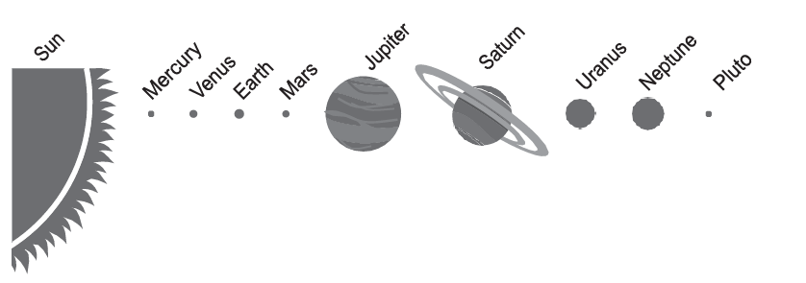

Planet | Mean Distance from the Sun  (x 1000000km) | Diameter  (Km) | Number of Moons | Mean Orbital Speed  (Km/s) | Time to Orbit the sun  (Earth Years) | Length of day  (hours)
Mercury | 58 | 4,880 | 0 | 48.0 | 0.24 | 1416
Venus | 108 | 12,100 | 0 | 35.0 | 0.62 | 5832
Earth | 150 | 12,760 | 1 | 30.0 | 1.00 | 24
Mars | 228 | 6,800 | 2 | 24.0 | 1.88 | 24.6
Jupiter | 778 | 143,800 | 16 | 13.0 | 11.86 | 9.84
Saturn | 1427 | 120,000 | 18 | 10.0 | 29.46 | 10.23
Uranus | 2870 | 52,300 | 15 | 6.8 | 84.01 | 17.24
Neptune | 4497 | 49,500 | 8 | 5.4 | 164.79 | 18.4
Pluto | 5900 | 3,000 | 1 | 4.7 | 247.70 | 153.4

- Which one of the following statements is best supported by the data?
  - Day length increases as distance from the Sun decreases.
  - Orbital speed increases as year length decreases.
  - Diameter increases as orbital speed increases.
  - Year length decreases as diameter increases.

- Which of the following statements is best supported by the data?
  - Planets further from the Sun travel faster and therefore have shorter days.
  - Planets closer to the Sun travel faster and therefore have shorter days.
  - Planets with longer days travel slower and are closer to the Sun.
  - Day length is unrelated to average orbital speed and distance from the Sun.

- Which of the following planet has closest value of length of day hours closest to earth’s length of days?
  - Mars
  - Uranus
  - Neptune
  - Jupiter
- Which of the following planets has the longest length of day in earth hours?
  - Neptune
  - Mercury
  - Pluto
  - Venus

John, a plumber, charges for work done in people’s homes as follows:
• $60.00 to go to the home, which includes a maximum of 15 minutes work; plus
• $15.00 for any part of each 15 minutes’ work after the first 15minutes.
- John calls at Mr Pauls home and does an hour and twenty minutes ‘work. His charge will be?
  - $75.00
  - $90.00
  - $12.00
  - $13.00
  - $15.00
John wants to set up a computer program to automate his billing of customers. The illustration below shows the stage he has reached in his planning of the flow chart for the program. There is nothing in the circle marked with an X at this stage.
- Without an instruction at X, a problem with this program is that it will.
  - Always charge customers too little.
  - Always charge customers too little, except for periods of 15 minutes or less.
  - Always charge customers too much, except for periods of 15 minutes or less.
  - Only charge customers correctly for periods of time that are exact multiples of 15 minutes.
  - Only charge customers correctly for periods of time that are not exact multiples of 15 minutes.

- Which one of the following instructions at position X would correct John’s program?
  - Subtract $15.00
  - Add $45.00
  - Subtract $45.00
  - Add $60.00
  - Subtract $60.00

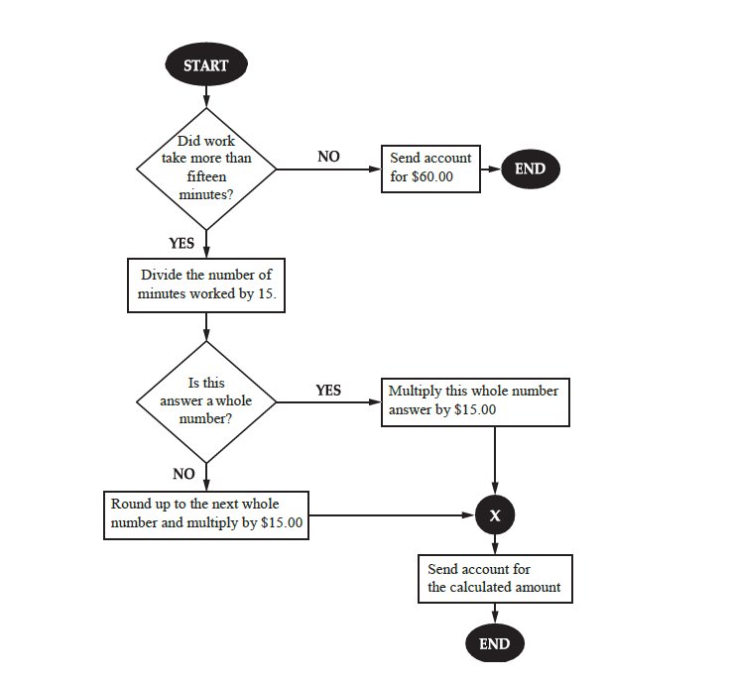
Davis has a duty of scheduling weekly gatherings of four groups at his university campus. The meetings are informed to convey at various locations at noon between Monday and Friday. Each group has one meeting each week. All the groups are to gather at noon when they do not have any class on their respective days. (Table 1)

CLUB | MEETING DAYS
COMMUNITY SERVICE  LEADERSHIP  ATHLETICS  THEATRE ARTS | MONDAYS AND WEDNESDAY  TUESDAY  MONDAYS AND THURSDAY  FRIDAYS

- People who join a club must attend all training sessions for that club

- Davis draws up four possible schedules for the meetings, shown below. Which one of these schedules does not involve a clash with another groups meeting?

 | M | Tu | W | Th |  | F
C |  |  |  |  | *
L | *
A |  |  |  | *
T |  |  | *

 | M | Tu | W | Th |  | F
C |  |  |  |  | *
L | *
A |  | *
T |  |  | *

 | M | Tu | W | Th |  | F
C |  |  |  |  | *
L |  | *
A |  |  | *
T | *

 | M | Tu | W | Th |  | F
C |  | *
L |  |  |  | *
A |  |  | *
T |  |  |  |  | *

  - All four schedules involve a clash.

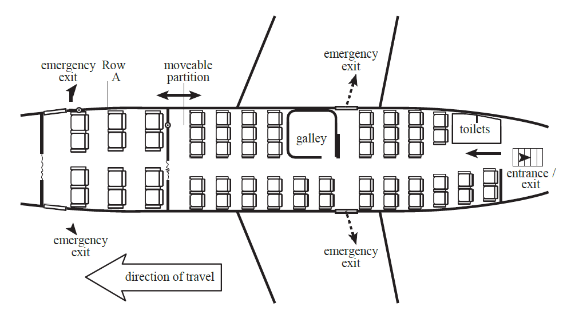

Khada Airways has a new brand of aircraft, the B-15. The plane flies passengers who pay Economy prices, and a smaller number who pay higher Business Class for more service and comfortability. Seat prices vary from flight to flight.
The B-15 has a rear entrance/exit. It has emergency exits over each wing and at the anterior part of the plane is the Business section. The layout of plane seating is shown in the figure above.
With this structure, seats in Rows D and J in Economy each have extra legroom. All Business class come with extra legroom.
- How many seats are provided for passengers in Economy?
  - 23
  - 24
  - 36
  - 47

- Assuming that that for a particular flight, Business is full and the Business passengers pay $200 per seat. All but four available Economy seats are filled with passengers. Economy passengers pay $100 per seat. How much are the total fares from the flight?
  - $6,500
  - $6,700
  - $6,900
  - $7,100

- The armrests between adjacent seats can be raised out of the way for the seats in economy, except the seats with extra legroom.
When a flight is not full, people sometimes like to raise the armrests and stretch across three seats to sleep. How many passengers could sleep this way in Economy in a B-15?
  - 5
  - 7
  - 15
  - 21

- Assuming that a light lunch will be served on a B-15 flight. Two flight attendants each serve lunch at the rate of one meal per one and a half minutes. All Business seats are full, and all but seven Economy seats carry passengers. How long does it take to serve all the passengers?
  - 26 minutes
  - 35 minutes
  - 39 minutes
  - 78 minutes
- A certain jar contains 60 balls—22 white, 18 green, 11 yellow, 5 red, and 4 purple. If a ball is to be chosen at random, what is the probability that the ball will neither be red nor purple?
  - 0.09
  - 0.15
  - 0.54
  - 0.85

- If a ball is chosen at random, what is the probability that the ball chosen is white?
  - 0.54
  - 0.4
  - 0.02
  - 0.14
A certain recipe requires three cups of Flour and makes 2 dozen cookies. (1 dozen = 12).
From the answer choices given, select and indicate the one that describes the relationship between quantity A and quantity B.
- Quantity A: The amount of sugar required for the same recipe to make 30 cookies
Quantity B: 4 cups
  - Quantity A is greater.
  - Quantity B is greater.
  - The two quantities are equal.
  - The relationship cannot be determined from the information given.

- Quantity A: The amount of sugar required to make 42 cookies using the same recipe
Quantity B: 5$\frac{1}{2}$ cups
  - Quantity A is greater.
  - Quantity B is greater.
  - The two quantities are equal.
  - The relationship cannot be determined from the information given.

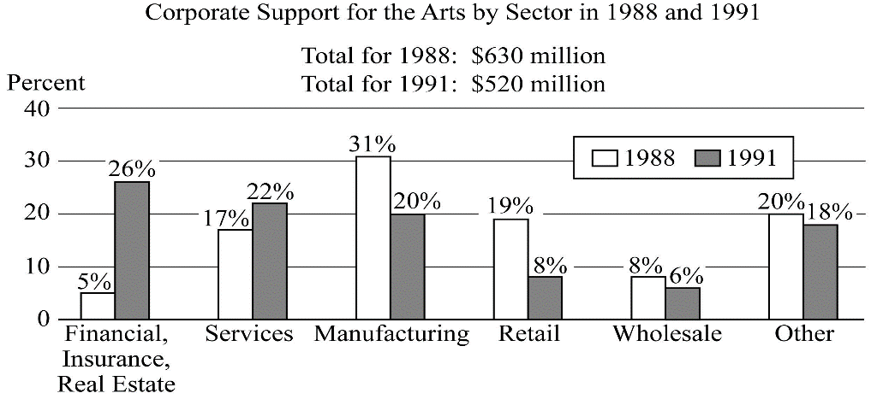
The data is given in a bar graph above is the graph of Corporate Support for the Arts by Sector in 1988 and 1991. The Total for 1988 is $630 million and the Total for 1991 is $520 million.
The question have five answer choices, labelled A through E. Select the best one of the answer choices given. Select and indicate the best one of the answer choices given
- How many of the six corporate sectors listed contributed more than $52 million to the arts in 1988?
  - 1
  - 2
  - 3
  - 4
  - 5

- Which corporate sector increased its support for the arts by the greatest amount between 1988 and 1991?
  - Services
  - Other
  - Retail
  - Wholesale
  - Manufacturing

- How many corporations gave a combined donation lower than $100 million?
  - 1
  - 3
  - 2
  - 5
  - None

- Of the 750 participants in a professional meeting, 450 are female and one half $\frac{1}{2}$ of the female and $\frac{1}{4}$ one fourth of the male participants are less than thirty years old. If one of the participants will be randomly selected to receive a prize, what is the probability that the person selected will be less than thirty years old?
  - $\frac{1}{8}$ one-eighth
  - $\frac{1}{3}$ one-third
  - $\frac{3}{8}$ three eighths
  - $\frac{2}{5}$ two-fifths
- What is the ratio of female participants less than thirty years to the entire population?
  - 2:5
  - 3:10
  - 1:8
  - 3:4

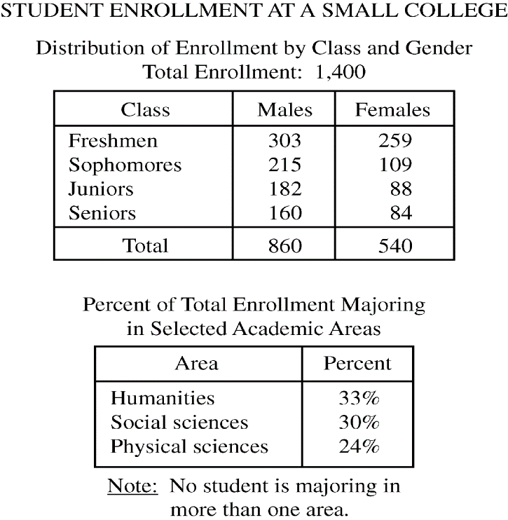
The table shows the Distribution of Enrolment by Class and Gender.
The second table shows the Percentage of Total Enrolment Majoring in Selected Academic Areas. No student is majoring in more than one area. The following questions have five answer choices, labelled A through E. Select the best one of the answer choices given.
- The ratio of the number of male freshmen to the number of female sophomores is approximately
  - 2.78
  - 3.1
  - 0.32
  - 1.45
  - 3.45

- If the total enrolment is 12 percent greater than it was five years ago, what was the total enrolment five years ago?
  - 1,180
  - 1,192
  - 1,220
  - 1,232
  - 1,250

- Which of the following statements must be true?
Indicate all such statements.
  - The number of males majoring in physical sciences is greater than the number of females majoring in that area
  - Students majoring in either social sciences or physical sciences constitute more than 50 percent of the total enrolment.
  - The ratio of the number of males to the number of females in the senior class is less than 2:1.
  - None of the statement are true
- What is the ratio of junior females to senior males?
  - 1:7
  - 5:8
  - 11:20
  - 5:11

- Which of the values is the closest to the percentage of males in the entire school?
  - 60%
  - 45%
  - 83%
  - 72%

Given that an equilateral quadrilateral A, B, C, D has one of its sides as 5.
From the answer choices given, select and indicate the one that describes the relationship between quantity A and quantity B.
- Quantity A: The perimeter of the shape
Quantity B: 15
  - Quantity A is greater.
  - Quantity B is greater.
  - The two quantities are equal.
  - The relationship cannot be determined from the information given.

- Quantity A: The Area of the shape
Quantity B: The Square of the length of a side.
  - Quantity A is greater.
  - Quantity B is greater.
  - The two quantities are equal.
  - The relationship cannot be determined from the information given.

- During the day, a statue which stands at 12feet, has a shadow of 8 feet on the ground at the same time, an upright pole casts a shadow of 10 feet on the earth. If the lengths of the shadows are proportional to the heights of the pole, what is the height of the taller object?
  - 10
  - 12
  - 14
  - 15
  - 18
From the choices given, select the best one of the answer choices.
Set D: 28, 23, 30, 25, 27
Set V: 22, 19, 15, 17, 20.
- The median of the numbers in the set of number in the group D is how much greater than the median of the numbers in group V?
- 8
- 10
- 12
- 13
A Rectangle Q has breadth of 10 and a height of 30, and a square T has a length of 5.
- The perimeter of Q is what fraction of the perimeter of T?
  - ¼
  - ½
  - 1/8
  - 2/3
  - 0.08

- The ratio of the area of the square to that of the rectangle is?
  - 1:8
  - 1:12
  - 2:5
  - 1:3
  - 3:8
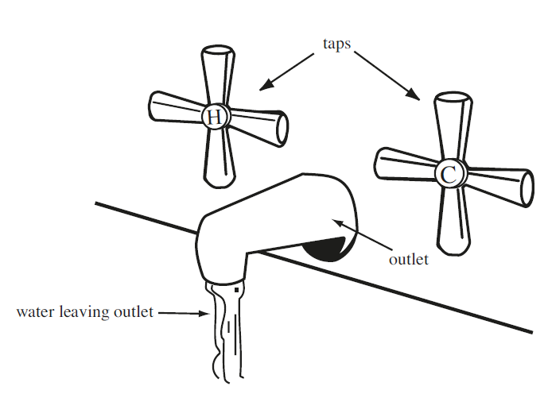
Assuming that Cold and hot water enters the outlet at the rate of 30L/min and 60L/min respectively.
- How much water enter the bath every minute?
  - 180L
  - 90L
  - 80L
  - 45L

- How much water enter the bath every twenty seconds if the flow rate of the Cold water is reduced by half?
  - 25L
  - 20L
  - 90L
  - 30L

- How much water enter the bath each 20 seconds?
  - 90L
  - 30L
  - 60L
  - 20L

- What is the ratio of the flow rate of the cold to the hot?
  - 6:1
  - 2:1
  - 1:2
  - 1:5

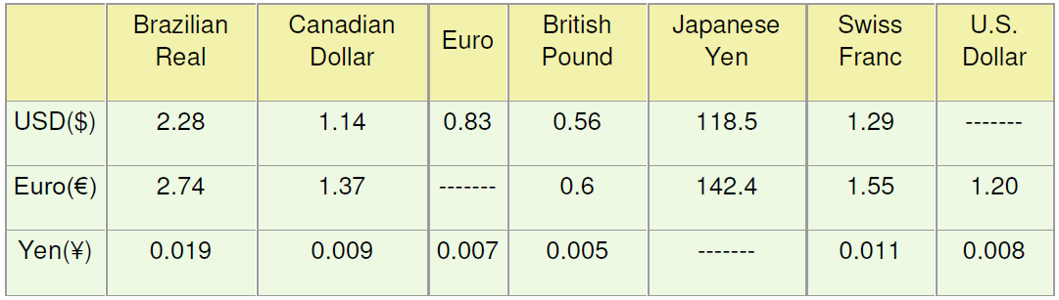
The table above shows the conversion rate of various currencies.
- A futuristic prediction about a recession in japan has reduced the value of yen by 7% as compared to the euro. How many euros can one get for 500 Yen?
  - 3.5
  - 3.26
  - 3.15
  - 3.76
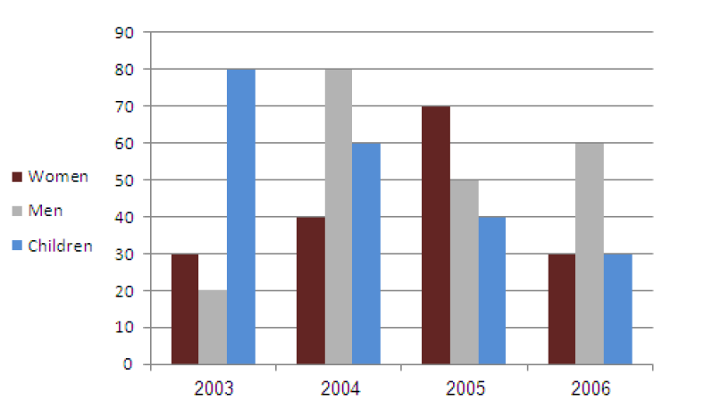
The graph above shows the daily average number of swimmers at Florida beach
- In which year was the average number of daily swimmers the highest?
  - 2003
  - 2004
  - 2005
  - 2006

- If the children group consists of equal number of boys and girls, how many more males swam at Florida beach in 2006 than in 2005?
  - 35
  - 45
  - 10
  - 5
- Together, two sports clubs (A and B) have x members; A has a members and B has b members. Some of the persons are members of both sports clubs. Which of the following expressions describes how many persons are members in only one of the two sports clubs?
  - x + a – b
  - 2(a + b) - 2x
  - ab - 2x
  - x - (a + b)

- Mary and her three siblings John, Martha and Davis are an average of 5 years old. John is 2, Martha 6 and Davis 7. Mary, her cousin Hanna, Hanna's brother Edward (18), Hanna's sister Doris (6) and Hanna's brother Adolf (1) are an average of 10 years old. How old is Mary's cousin Hanna?
  - 5
  - 10
  - 15
  - 20

- 2,600 bottles contain 650 litres of a soft drink. How many litres do 5,000 bottles hold?
  - 338 litres
  - 1,000 litres
  - 1,250 litres
  - 1,300 litres

The distance between Texas and New York is 400 Kilometres
The distance between New York and Oregon is 300 Kilometres
The distance between Oregon and Florida is 200 Kilometres.
- The distance between Texas and Oregon Is?
  - 100
  - 500
  - 700
  - Value cannot be determined from the information given

- The distance between Texas and California is?
  - 800
  - 600
  - 900
  - Value cannot be determined from the information given

- Two boys Chris and Alex brought in coconuts from the farm to the house, Chris carried sixty five 65 buckets coconuts, and Alex brought in 50 coconuts. If each bucket can contain only fifteen coconuts, how many trips altogether did the boys take?
  - 9
  - 12
  - 10
  - 7

- How many more trips did the first boy take more than the second?
  - 2
  - 1
  - 15
  - 4

- In a soccer team, there are 42 players, half of the players are above thirty years and from the remaining half one third are below twenty.
How many players are between twenty to thirty years of age?
  - 12
  - 21
  - 7
  - 14

- What is the ratio of players below twenty years to the players above thirty years?
  - ½
  - 1/3
  - ¼
  - 1/7

